Python
python is high level interpreted programing language developed by Guido van Rossam in 1991
// module import
From file_name import model_or_funtion
Model(__variable__)
// Python Inner Working
Python file.py -> byte code ->Python virtual machine ->output
Byte code are hidden in the python

Steps ->
Step1->
Python ->byte code -> python virtual machine ->machine code -> output

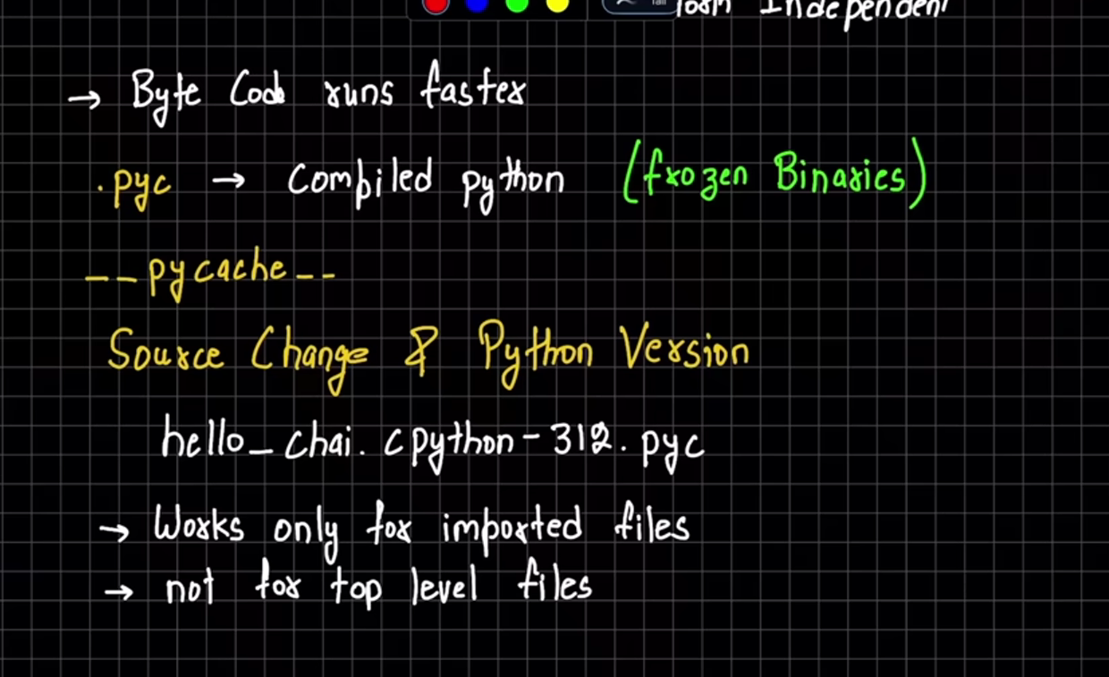
The hello_chai.cpython-312.pyc that shows the python version 3.12
These .pyc file create when the import the files used in programming
*PVM :- these perform the loop to iterate the byte code
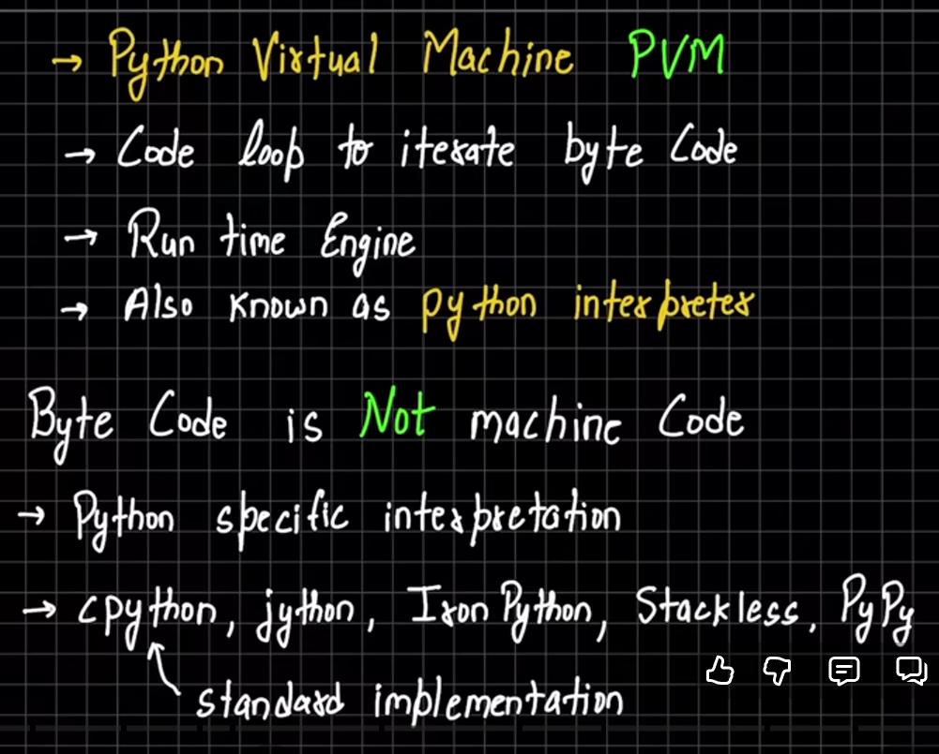

// Python Shell

